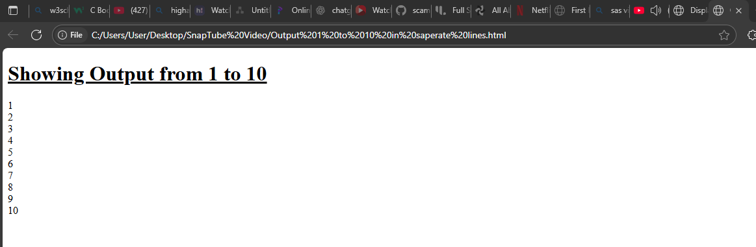
<!DOCTYPE html>
<html>
<head><title>Output from 1 to 10 </title></head>

<h1><u>Showing Output from 1 to 10</u></h1>
<body>
<p>
1 <br>
2 <br>
3 <br>
4 <br>
5 <br>
6 <br>
7 <br>
8 <br>
9 <br>
10 <br>

</p>
</body>

</html>

